
PRENATAL SMARTWATCH

Nandita Reji
BEng(H) in Software & Electronic Engineering
Atlantic Technical University
2025/2026

Project Description

Pregnancy is a natural process for women who chooses to have it. However not all women experience pregnancy the same way. Studies show the occurrence of prenatal depression is 20-40% higher whereas post-partum depression is 17% and affects the foetus development through the mother. It can also lead to abortion, complications, post-partum depression and premature birth. Since the growth of the baby is linked to the mother, it is crucial for the mother to be in a good mental state throughout her pregnancy.

Since exercise is a way to alleviate depression, in this IoT project, I will be producing a fitness smartwatch that tracks the health data of pregnant women. This device displays the pelvic floor exercises during their pregnancy and tracks their behaviour throughout the day. It reads their heart rate and makes sure it is at a normal pace and reads their blood oxygen and alerts the user if abnormal. It checks their temperature, counts the steps and displays it on the screen. The Thing Speak server is useful to show all the data processed from the components. It can put them in a better mental state when they see the statistics on the screen.
The ESP 32 chip will be combined with infrared sensor (RPR-220) to check blood oxygen, an accelerometer to count the number of steps, a temperature sensor that tracks the basal body temperature and a LCD screen to display the activity. I will be using the C++ language with Arduino to create the interface. This watch promotes the overall wellbeing of both the woman and the baby.

Architecture Diagram

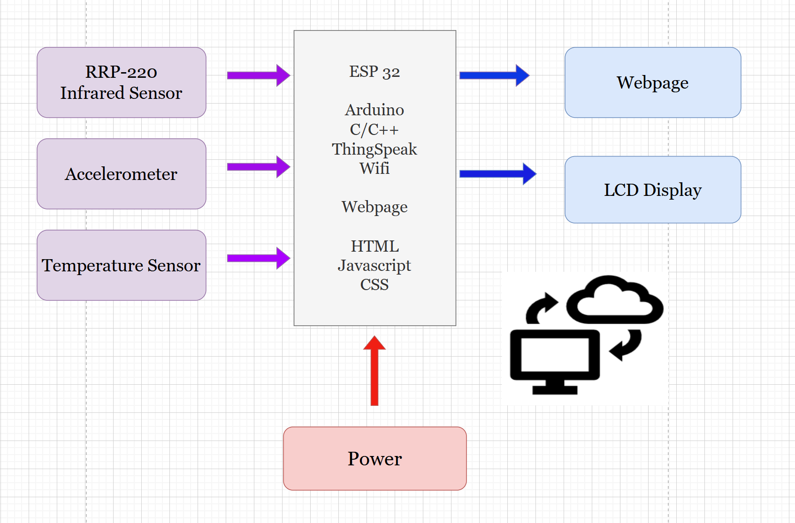

Feasibility

The only hard part is to figure out the infrared sensor for coding and installing however most of the project is feasible.

Meeting United Nations’ Sustainability Development Goals UN SDGs

My project is linked to Goal 3 from the UN’s Sustainable Development Goals which is Good Health and Wellbeing. This watch helps women monitor progress and encourages them to be healthy during their pregnancy period.

Schedule

October: Learn about the infrared sensor more and the software used. Gather all the components and piece it together before putting it on the breadboard.

November: Build the circuit on the breadboard. See what is and what is not working. Make any last-minute changes. Try not to fry the ESP32.

December: Compile and test code and upload it to ThingSpeak. Add finishing touches to the project.

References

[1] | United Nations, “The 17 Goals Sustainable Development,” [Online]. Available: https://sdgs.un.org/goals. [Accessed 02 October 2025].
[2] | Alexander Muacevic, John R Adler, "Untreated Depression During Pregnancy and Its Effect on Pregnancy Outcomes: SystematicReview[Online] https://pmc.ncbi.nlm.nih.gov/articles/PMC8448270/[Accessed 01 October 2025].
[3] HSE “Benefits of physical activity during pregnancy “https://www2.hse.ie/pregnancy-birth/keeping-well/exercise/benefits-exercising/[Accessed 03 October 2025].

